

KGiSL INSTITUTE OF TECHNOLOGY

**Project_Title : Website Traffic Analysis**

**Mentor :** Indu Poornima R

**Team Members :**

NAVEEN SG

RAVINDRANATH M

LOKESH KV

BALAGANESH M

**Project Description :** Website traffic Analysis

**Objective :**

Web traffic analysis is the process of examining and interpreting the data related to the visitors and interactions on a website. The objective of web traffic analysis is to gain insights into how users interact with a website, what content they engage with, where they come from, and more.

**Calculating the daily traffic data :**



These are demographic analyses of marginal workers of Tamilnadu in the industrial category.

OUTPUT:

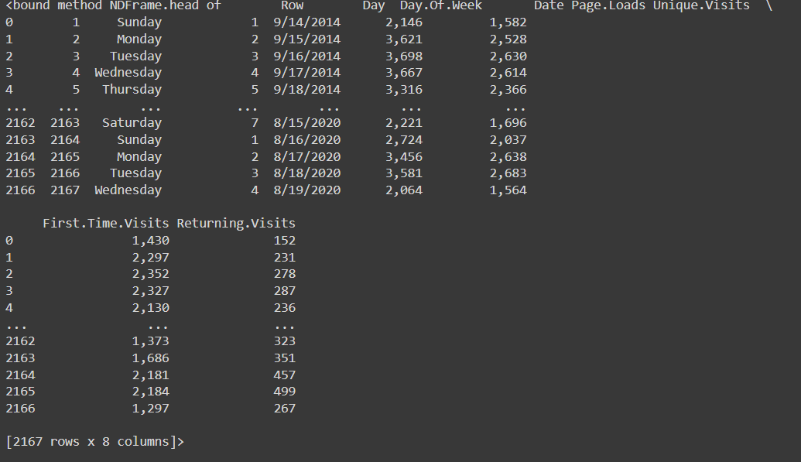

**Calculating the traffic group data :**

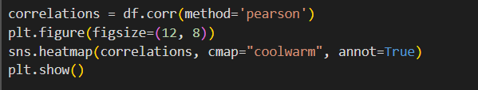

**OUTPUT:**

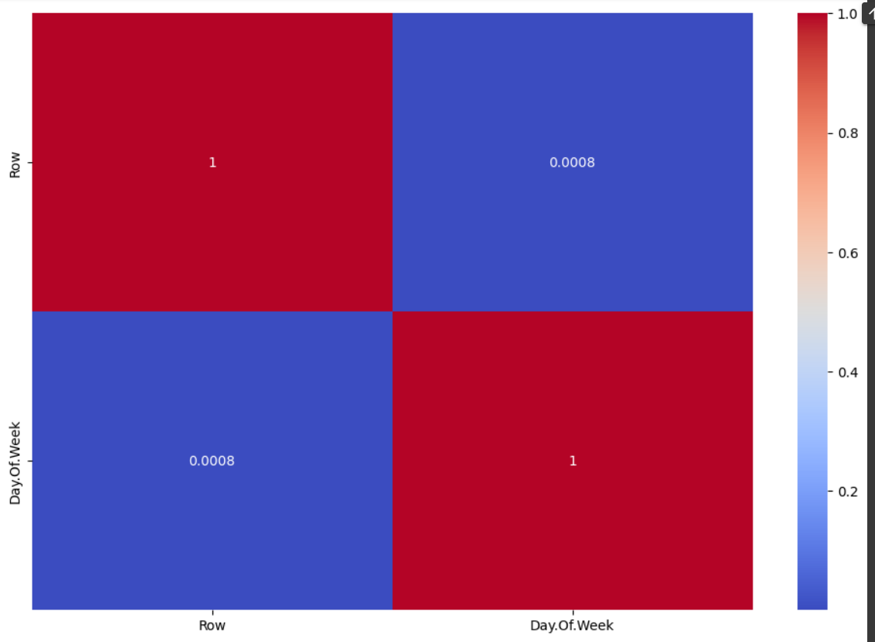

**Calculating the access analysis :**

